**Experiment 8**

**Student Name:** Sahil Kaundal **UID:** 21BCS8197

**Branch:** CSE (Lateral Entry)  **Section/Group:** 616/A

**Semester:** 6th **Date of Performance:** 03/05/2023

**Subject Name:** Internet of Things Lab **Subject Code:** 20CSP-358

1. **Aim:**

## **Interfacing Air Quality Sensor (MQ135), displays data on LCD**.

1. **Objective:**

* Learn about LCD in detail.
* Learn about IoT programming.
* **Interfacing Air Quality Sensor (MQ135), displays data on LCD**.

1. **Requirements:**

* Arduino Uno R3 board
* LCD
* Jumper Wires
* MQ135 Air Quality Sensor.

1. **Procedure:**

**About Air Quality Sensor:**

MQ-135 sensor belongs to the MQ series that are used to detect different gasses present in the air. The MQ-135 sensor is used to detect gases such as NH3, NOx, alcohol, Benzene, smoke, CO2, etc. steel exoskeleton houses a sensing device within the gas sensor module.

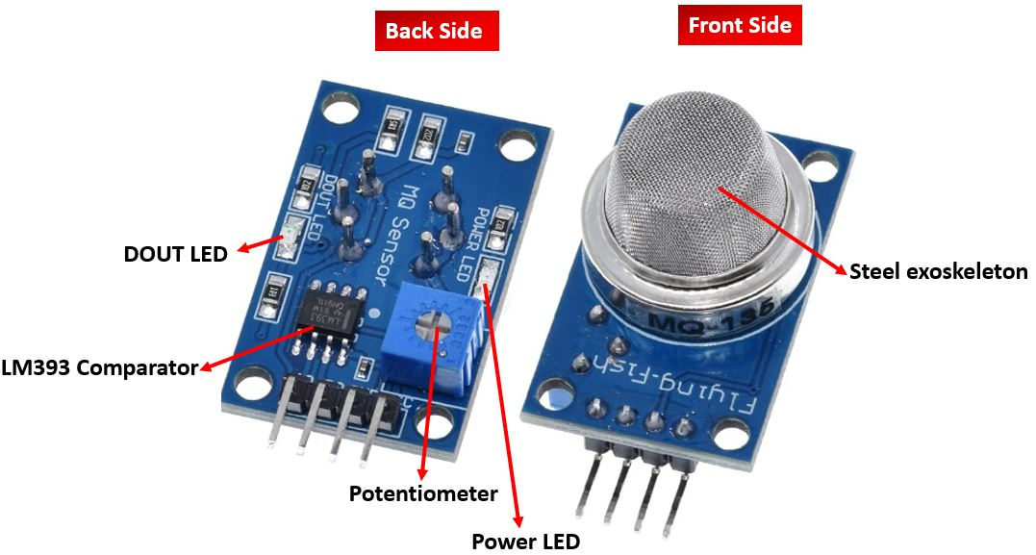

#### **Specifications**

The table below shows some key specifications of the MQ-135 sensor module:

| **Feature** | **Description** |
| --- | --- |
| Operating Voltage | 2.5-5.0V |
| Detecting Concentration | 10ppm-300ppm for NH3 10ppm-1000ppm for Benzene 10ppm-300ppm for Alcohol |
| Load Resistance | Adjustable |
| Heater Resistance | 33Ω ± 5% |
| Heater Consumption | less than 800mW |
| Operating Temperature | -10 to 45°C |

#### **Pinout**

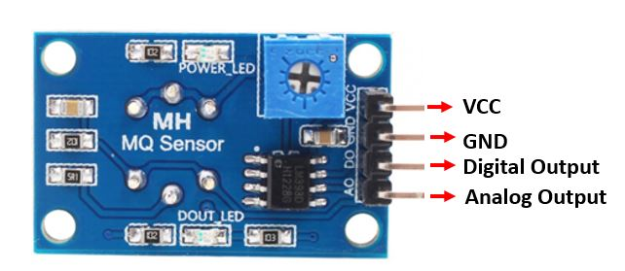

##### **MQ-135 Sensor Pinout**

##### **This sensor has 4 pins:**

##### 5V: Module power supply – 5 V

##### GND: Ground

##### DOUT: Digital output

##### AOUT: Analog output

**Circuit**

The MQ-135 sensor module consists of four pins namely VCC, GND, DO, and DO. The table below gives a brief description of them.

| **Pin** | **Description** |
| --- | --- |
| VCC | Positive power supply pin that powers up the sensor module. |
| GND | Reference potential pin. |
| AO | Analog output pin. It generates a signal proportional to the concentration of gas vapors coming in contact with the sensor. |
| DO | Digital Output pin. It also produces a digital signal whose limit can be set using the in-built potentiometer. |

1. **Steps/Program:**

int sensorValue;

int digitalValue;

void setup()

{

Serial.begin(9600); // sets the serial port to 9600

pinMode(13, OUTPUT);

pinMode(2, INPUT);

}

void loop()

{

sensorValue = analogRead(0); // read analog input pin 0

digitalValue = digitalRead(2);

if (sensorValue > 400)

{

digitalWrite(13, HIGH);

}

else

digitalWrite(13, LOW);

Serial.println(sensorValue, DEC); // prints the value read

Serial.println(digitalValue, DEC);

delay(1000); // wait 100ms for next reading

}

#include "LiquidCrystal.h"

LiquidCrystal lcd(8,7,6,5,4,3);

int GAS_VAL = 0;

void setup()

{

pinMode(A0, INPUT);

Serial.begin(9600);

lcd.begin(16,2);

lcd.setCursor(0,0);

lcd.print(" Experiment 7 ");

}

void loop()

{

GAS_VAL = analogRead(A0);

Serial.println(GAS_VAL);

if (GAS_VAL > 500)

{

lcd.setCursor(0,1);

lcd.print(" GAS Detected");

}

else

{

lcd.setCursor(0,1);

lcd.print(" GAS Not Detect");

}

delay(10); // Delay a little bit to improve simulation performance

}

1. **Output:**

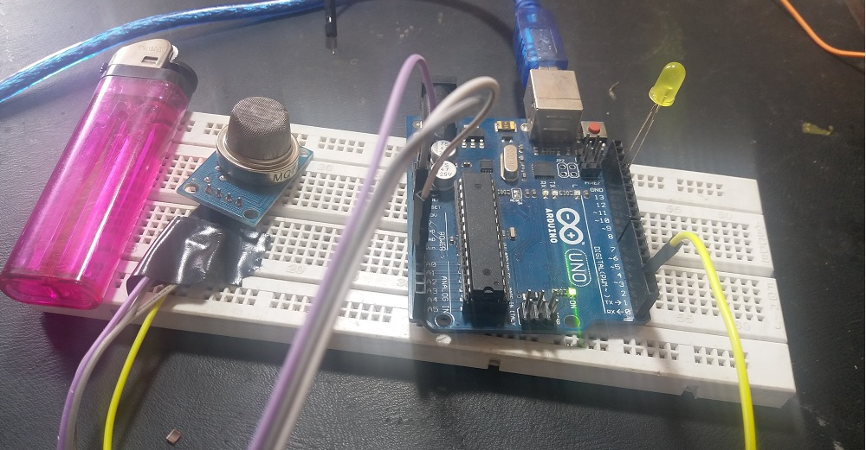

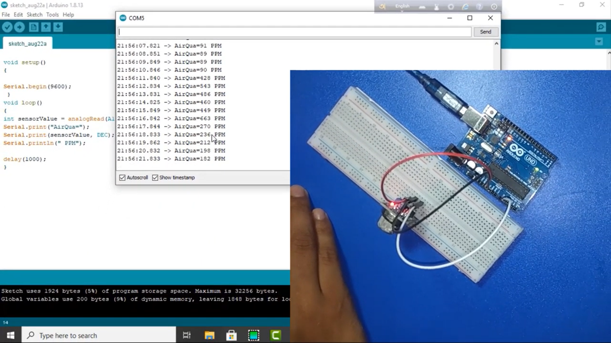

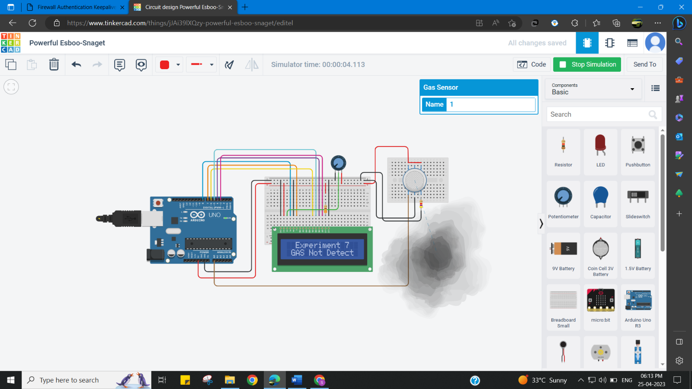

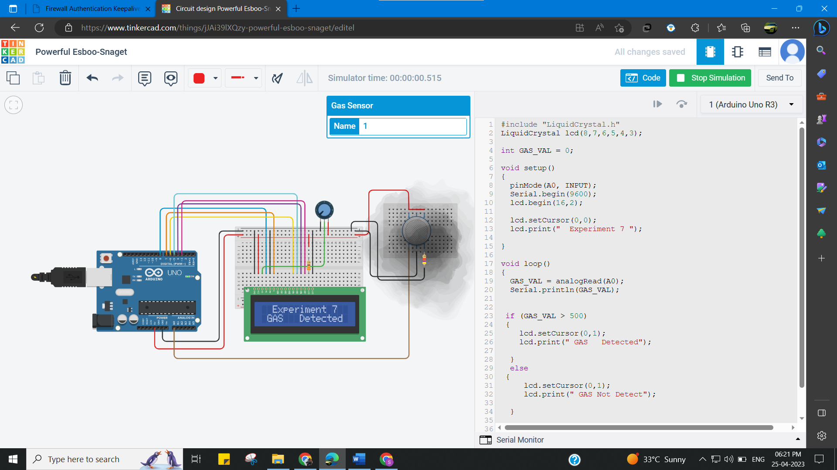

**Learning outcomes (What I have learnt):**

* Learn about LCD in detail.
* Learn about IoT programming.
* **Interfacing Air Quality Sensor (MQ135), displays data on LCD**.